Holden Clough Community Primary School

Parents’ & Carers’ Survey
April 2022

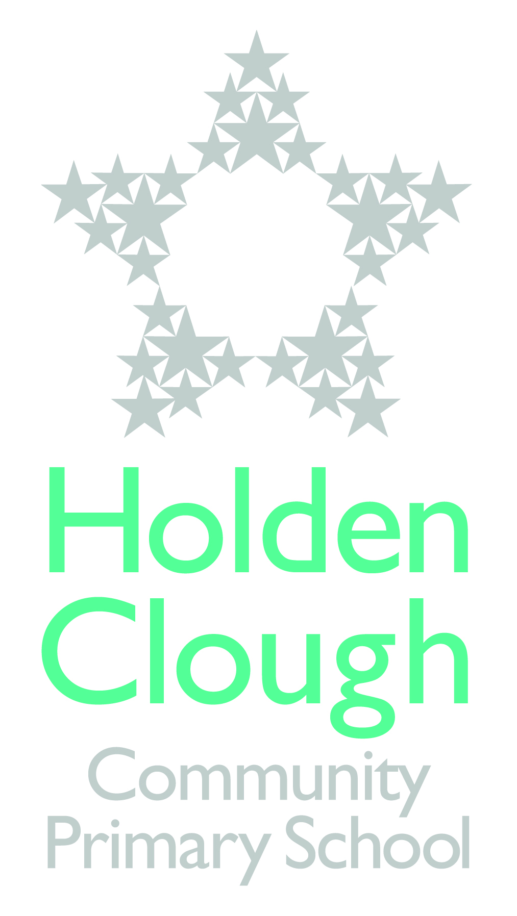

Your Views Count!

You may remember that at the last parents’ evening we offered all parents the chance to complete a survey. We are sharing the results of the survey with you and also the actions that we will take based on the responses that you gave.
It is always pleasing when you tell us how well we are doing. We like to know that we are meeting the high expectations that you have of us. Equally, we need to know when we could do things differently to improve what we can offer for you and your child.
We would like to thank every parent who took the time to complete the questionnaire on offer at the Parents’ Evening in April 2022. We really do value your feedback and use the data it provides us to further improve the provisions for your child.

- This document presents the results of our Parents Evening Parent/Carer Views. The Survey was carried out in April 2022.
- This Survey – and the other smaller surveys we carry out from time to time – will help to shape the ongoing development of the school.
- Thank you to all parents/carers who completed our Survey.

Overall Results of the Survey
90 parents/carers responded.

 |  | Strongly Agree | Agree | Neither  Disagree/agree | Disagree | Strongly  Disagree | Total % in Agreement
1 | My child enjoys coming to  school. | 60%  (53) | 32%  (28) | 6%  (5) | 4%  (3) | 0 | 92%
2 | My child is well looked after at this school. | 63%  (56) | 33%  (29) | 5%  (4) | 0 | 0 | 96%
3 | My child’s class teacher is approachable and effective if I have any issues with my child. | 70% (63) | 23% (21) | 4%  (4) | 1%  (1) | 1%  (1) | 93%
4 | The senior leadership team; Assistant Head, Deputy Head and Headteacher, are approachable and effective if I have an issue with my child. | 51% (46) | 36% (32) | 10%  (9) | 2%  (2) | 1% (1) | 87%
5 | The school expects and maintains a good standard of behaviour from pupils. | 60% (53) | 37% (33) | 2%  (2) | 1%  (1) | 0% | 97%
6 | The school communicates with parents well (e.g. letters, emails, newsletters, website, class dojo) | 52% (47) | 37% (33) | 6% (5) | 4%  (4) | 1%  (1) | 89%
7 | Holden Clough deals effectively with bullying | 30% (27) | 33% (29) | 34% (30) | 2%  (2) | 1%  (1) | 66%  (97%)
 | It is worth noting that only 34% of all parents neither disagree/agree with this, which means that – potentially – 97% agree! The reason the ‘Agree’ figure is 72% is because our newer families simply don’t know enough about the measures we take to promote an Ant-Bullying message, and the tangible and effective activities and strategies in place to ensure that the children understand how important it is to be kind and caring, and what to do if there is any sign of bullying. Some children haven’t experienced bullying
8 | I am kept informed about the progress of my child. | 36% (32) | 49% (44) | 8%  (7) | 7%  (6) | 1%  (1) | 85%
9 | The school offers adequate and varied after school activities. | 32% (29) | 43% (39) | 13% (12) | 10%  (9) | 1% (1) | 95%

14 | I will recommend Holden Clough to other parents | YES | 95.51% (85)
 |  | NO | 4.49% (4)

Parents agree overwhelmingly that Holden Clough Community Primary is a safe place for their child and they are well looked after. We are delighted that 92% of children enjoy coming to school. We have several systems & procedures to ensure that we are a safe school – for example our Safeguarding systems, site security, anti-bullying policies etc. We have effective internet filtering systems, and we teach the children about staying safe online. We strongly promote mutual respect and we encourage the children to be caring toward each other. Of course, childhood is a fluid time and friendships change and disagreements can happen but 97% of our parents testify that their child has confidence in the team at Holden Clough to provide a supportive and caring environment where good learning can take place.

A few parents and carers responses to additional comments, questions, or concerns they would like to add

(Please note that these are all individual points, from individual parents/carers/families)

- I cannot fault this school or the teachers in it.

- Holden Clough has a wonderful sense of community with children's happiness and wellbeing at its heart. We felt the warm and welcoming family atmosphere from the moment we walked through the door 6 years ago. I have always been very supported as a parent and love how staff support children to reach for the stars and be the best they can be. I am proud to be a parent of the school and always recommend it to others.

- We cannot praise enough Holden Clough Primary School. Our children love going to school and look forward to all the fun activities and studying in groups. They feel very supported and my 3 children integrated straight away as soon as they joined Holden Clough. We are so grateful for having found such a good school for our children.

- Lovely school and younger child looking forward to starting come September.

- Holden Clough has provided an inspiring school for both my children, I am grateful they had the opportunity to develop and be prepared for the next step.

- Emilia has loved her first year at Holden Clough and we have been very happy with our experience.

- Fab school and great teachers. What more could we ask for!

Comment from Parent/Carer | Our Response
EYFS (YN & YR)
Reception aren’t included in the newsletter | All year groups take it in turns to put pieces of work in the newsletter. We try to put information on our dojo class pages to show case our work.
I feel the school needs to be consistent in maintaining punctuality of the doors being open on time in the mornings and when school finishes. Parents should not have to wait, the school needs to be considerate of the parents as they have other responsibilities to attend to. This is not the case for all classes but quite often for year 4 doors | Thank you for raising this issue. We will make staff aware of how it can impact on other responsibilities parent do have at either end of the day.
Y1
Homework - I feel as though homework could be more targeted to learning taking place in school. At the moment it is too vague and not targeted for the individual needs of the child. | Homework in Year one is set to reflect the learning taking place in the half term. Home work is to embed learning that has taken place and also prepare them for later in life. The children have reading eggs and numbots that will be more targeted to their individual need
I've not experienced all of the above so can't comment on every question. I don't feel communication is a strong point and having not been inside the school since my daughter started it's hard to know how behaviour is handled or how she is being looked after. We've not seen any books and rarely any photos of what happens during the day. When I've queried something with the school I haven't always had a call back and while I appreciate how busy it can be, it can get frustrating not being kept informed. | Thank you for your feedback. We realise that for our new families starting school during the pandemic has been difficult. We will be making adjustments to how we conduct parents evenings to allow parents to see books and displays in the school.  Please contact school again if you feel queries have not been responded to  We pride ourselves on having an open door policy and always want to resolve any issues with parents
Y2
After schools to support children who struggle with reading and writing | We currently have clubs for children who are struggling in certain areas and they are done by invitation. We have homework clubs and tutoring for year groups 3 upwards.
Y4
Would like to have more snacks given in class | Snacks are made available for Nursery to Year 2 as part of the free fruit for schools unfortunately this does not carry on into year 3 so we ask parents to send in a healthy snack from home for break time.
Would like after school clubs to run for more than 1 term | We try to give the children a variety of experiences in different sports or extra curricular clubs.
More punishment for not completing homework | We try to encourage children to read everyday by giving out raffle tickets to enter the draw at the end of the week. We have a homework club on a Tuesday to support children who are completing homework at home.
Y5
Would it be possible for more after school football for year 5. They are all heavily interested in it. But are finding it is not available after school. | We try to vary the clubs the children experience so they can learn different sporting skills and cater for other children’s likes and dislikes.
Guitar lesson would be great for yr5/6 they are now at a good age to handle instruments | We buy into the music service with Tameside. Children start to learn different instruments from year 3.
My child mentions he’s bored with Maths, as it doesn’t challenge him. | Thank you for the feedback. Please contact the class teacher if you would like to discuss this further. All children should feel challenged in class.
Not even sure who the senior leadership team are and they haven't really made themselves known so can't approach | Thank you for this feedback the senior leadership team are on our website. We understand if you are a new parent to school this may not be obvious but we try our best to introduce many members of staff as we show you around our school.
Y6
Bullying No one saw, no one told, no action taken. Not all children are confident enough to tell a member of staff as fear of being labelled a telltale and making things up. Special treatment for children with problems | Thank you highlighting this issue. At Holden Clough we take bullying seriously. We really want every child to feel happy while they are at school. Bullying complaints will be dealt with firmly, fairly and promptly and will require the full support of parents. If you have any concerns regarding a child being bullied please contact the school as soon as possible.

