Create a non-chronological report about a desert of your choice, e.g. Sahara, Gobi, Syrian, Kalahari, Antarctica.

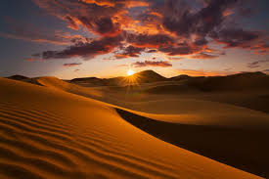

=

Carry out research to help you create a biography about Mother Teresa. Remember biographies are in chronological order from her birth through to her later years and death. It should include why she is famous and her achievements.

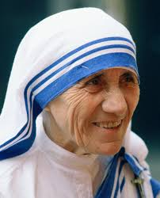

Create your own fraction game. It could focus on comparing and ordering fractions or equivalent fractions.

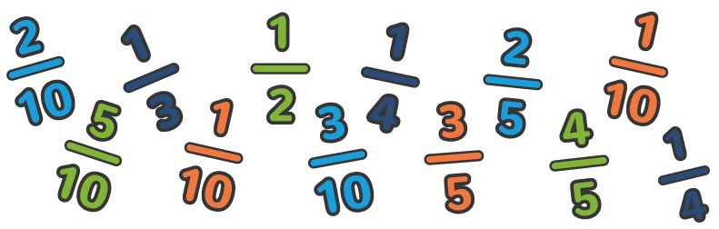

Holes is set in Texas and The Explorer is set in the Amazon rainforest. Choose either Texas or The Amazon and write a fact file about it.

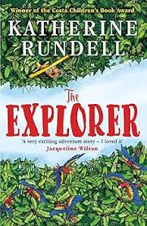 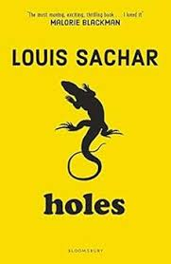

Create a piece of art work in the style of Italian painter Giacomo Balla.

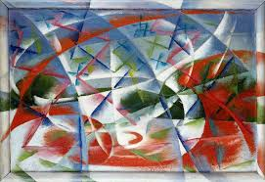

Homework Mat Spring 1 2025

Year 5CH and 5NH

Write a poem called ‘Belonging’. You could think about how it has two meanings (possessions/sense of belonging). Perhaps you’ll be inspired by an important belonging you have at home, or a place where you feel you belong. Be as creative as you like! 