Pupil Premium Strategy Statement 3 Year Plan – 2022-2025

This statement details our school’s use of pupil premium (and recovery premium for the 2022 to 2025 academic years) funding to help improve the attainment of our disadvantaged pupils.

It outlines our pupil premium strategy, how we intend to spend the funding in the coming academic years and the effect that 2023-24 year’s spending of pupil premium had within our school.

School overview
Detail | Data
School Name | Holden Clough Primary School
Number of pupils in school | 319
Proportion (%) of pupil premium eligible pupils | 23% (74 chn)
Academic year/years that our current pupil premium strategy plan covers | 2022/23  2023/2024  2024/2025
Date this statement was published | September 2024
Date on which it will be reviewed | September 2025
Statement authorised by | F. Kordemir/ Jo Hartley & Jenna Boult (Impact report prepared by A.Porter)
Pupil premium lead | Jo Hartley & Jenna Boult
Governor / Trustee lead | Ali Basharat
Funding overview
Detail | Amount
Pupil premium funding allocation this academic year | £109,520 (74x £1480)  (71x £1480)
Pupil premium funding carried forward from previous years (enter £0 if not applicable) | £0
Total budget for this academic year  If your school is an academy in a trust that pools this funding, state the amount available to your school this academic year | £109,520

Part A: Pupil premium strategy plan

Statement of intent
When making decisions about using Pupil Premium funding it is important to consider the context of the school and the subsequent challenges faced. This alongside research conducted by the EEF. Common barriers to learning for disadvantaged children can be: less support at home, weak language and communication skills, lack of confidence, more frequent behaviour difficulties and attendance and punctuality issues. There may also be complex family situations that prevent children from flourishing. The challenges are varied and there is no “one size fits all”.
We will ensure that all teaching staff are involved in the analysis of data and identification of pupils, through Pupil Progress meetings, so that they are fully aware of strengths and weaknesses across the school.
Principles
• We ensure that teaching and learning opportunities meet the needs of all the pupils
• We ensure that appropriate provision is made for pupils who belong to vulnerable groups, this includes ensuring that the needs of socially disadvantaged pupils are adequately assessed and addressed
• In making provision for socially disadvantaged pupils, we recognise that not all pupils who receive free school meals will be socially disadvantaged
• We also recognise that not all pupils who are socially disadvantaged are registered or qualify for free school meals. We reserve the right to allocate the Pupil Premium funding to support any pupil or groups of pupils the school has legitimately identified as being socially disadvantaged.
• Pupil premium funding will be allocated following a needs analysis which will identify priority classes, groups or individuals. Limited funding and resources means that not all children receiving free school meals will be in receipt of pupil premium interventions at one time.
Demography and School Context
Holden Clough Primary School is located in Ashton-Under-Lyne, in Tameside MBC. This is technically a two-form entry school with a part time nursery offering 26 places. The current admission numbers for 2024-2025 are low in Nursery (13 pupils) and the LEA Admissions department forecast is similar for the next 2 years. The school reduced the PAN last academic year, after a 2-year consultation process, to 30 places. 2024-25 will be the second year of our reception intake consisting of 30 children.
The map below displays the “Lower Super Output Areas” (LSOAs) which surround the school and they are colour coded according to which national decile they belong to: decile 1 being the most deprived and decile 10 being the least deprived (IMD rankings). The stars indicate where the school’s pupils live. Although there are areas relatively near to the school which have lower than average levels of deprivation, some of the areas immediately surrounding the school, in which most of the pupils live, are amongst the most deprived in the country.
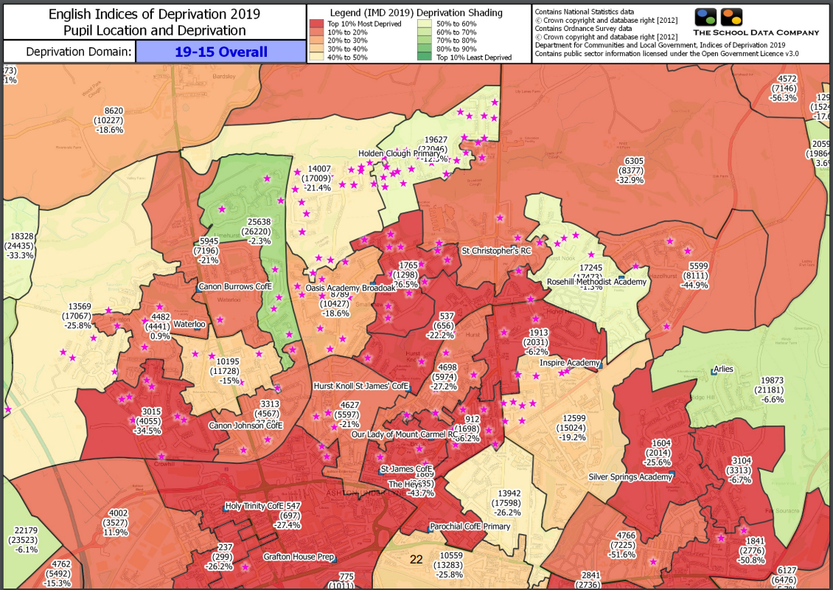
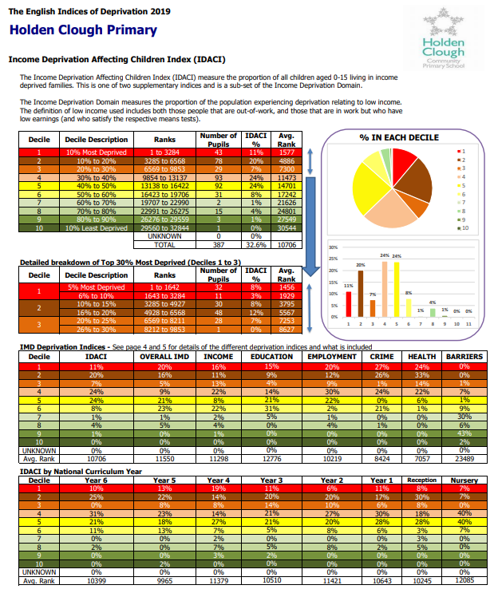
Ultimate Objectives
• To narrow the attainment gap between disadvantaged and non-disadvantaged pupils nationally and also within internal school data.
• For all disadvantaged pupils in school to exceed nationally expected progress rates in order to reach Age Related Expectation at the end of Year 6 and thus achieve GCSE’s in English and Maths.

Achieving These Objectives
The range of provision the Governors consider making for this group include and would not be limited to:
- Quality First Teaching across the school
- Focus on Oracy across the school
- Training of staff to deliver speech, language and communication interventions
- Implement Relational Inclusion
- Focus on ‘Writing for Pleasure’ strategies to improve pupil outcomes
- Commissioning a new writing curriculum
- Utilise LSAs effectively with a focus on tiered PP support
- 1:1 support
- Additional teaching and learning opportunities provided through trained LSAs or external agencies
- All our work through the pupil premium will be aimed at accelerating progress, moving children to at least age-related expectations.
- Pupil premium resources are to be used to target able children on Free School Meals to achieve Age Related Expectations
- Transition from primary to secondary and transition internally and into EYFS.
- Additional learning support.
- Pay towards activities, educational visits and residential trips. Ensuring children have first-hand experiences to use in their learning in the classroom.
- Support the funding of specialist learning software.
- To extend PE provision by buying specialist provision during and after school.
- To allow the children to learn a musical instrument and to sing in a choir.
- Behaviour and nurture support during lunchtimes by providing activities to engage and promote Holden Clough values and thus enhance learning.
This list is not exhaustive and will change according to the needs and support our socially disadvantaged pupils require.

Challenges

This details the key challenges to achievement that we have identified among our disadvantaged pupils.
Challenge number | Detail of challenge
1 | Reading skills are less well developed for pupil premium pupils than other pupils, particularly with fluency, stamina and in the understanding of vocabulary.
2 | Communication skills are less well developed for pupil premium pupils than other pupils, particularly attention and listening, understanding and expressing grammar, understanding and expressing vocabulary and expressive narrative. This is reflected in both their speaking and writing.
3 | Lack of a broad range of experiences and less well-developed vocabulary, can mean that writing is a barrier for many pupil premium pupils.
4 | Maths skills (particularly arithmetic and number facts) prevent some PP children from achieving ARE.
5 | A number of children who are in receipt of Pupil Premium who also have additional vulnerabilities/barriers such as: SEND, EAL, CP issues, difficult early life experiences, in year transfers, prior home education
6 | Social and emotional barriers which prevent some pupil premium pupils learning effectively.
7 | Lack of support from parents of some pupil premium children which results in lower attainment, attendance and lateness.
8 | Attendance and Punctuality issues. Pupil premium children in our school have lower attendance than our non-pupil premium children. It is also lower than the national average attendance for PP children.

Intended outcomes
This explains the outcomes we are aiming for by the end of our current strategy plan, and how we will measure whether they have been achieved.
Intended outcome | Success criteria
To improve progress in Reading | Achieve above national average progress scores in KS2 Reading (0)
Progress in Writing | Achieve above national average progress scores in KS2 Writing (0)
Progress in Mathematics | Achieve above national average progress scores in KS2 Maths (0)
Phonics | Achieve above national average expected standard in PSC
Other | Ensure attendance of disadvantaged pupils is above 95%

Activity in this academic year (2024/25)

This details how we intend to spend our pupil premium this academic year to address the challenges listed above.

Teaching (for example, CPD, recruitment and retention)
Budgeted cost: £57,570
Activity | Evidence that supports this approach | Challenge number(s) addressed | Cost
Whole class reading approach.  Pupils are experiencing more age appropriate texts and are hearing others model reading aloud. Pupils with lower reading ages are developing their vocabulary through exposure to more sophisticated texts | EEF Teaching & Learning Toolkit shows that reading comprehension strategies can have an impact of +6 months.  https://educationendowmentfoundation.org.uk/education-evidence/teaching-learning-toolkit/reading-comprehension-strategies | 1 & 2 | £3000
First Class Phonics  A consistent, progressive approach to teaching phonics.  Used as a whole class teaching method in EYFS & KS1 but also to target groups of older children at risk of reading failure due to decoding difficulties.  principles of learning to read. | EEF Early Years Toolkit shows that early literacy approaches can have an impact of +4 months.  https://educationendowmentfoundation.org.uk/education-evidence/early-years-toolkit/early-literacy-approaches  EEF Teaching & Learning Toolkit shows that phonics can have an impact of +5 months.  https://educationendowmentfoundation.org.uk/education-evidence/teaching-learning-toolkit/phonics  We have audited our reading book scheme to ensure it aligns with First Class Phonics and shows a cumulative progression in phonics knowledge. Purchasing additional books to fill in any gaps (2023-20234). | 1 & 2 | £1500
WellCom andTales Toolkit  A whole class approach where children lead their own stories and the adults model back the language. Helps to develop language, literacy, social skills, creativity confidence, empathy, writing and problem solving. | EEF Early Years Toolkit shows that early literacy approaches can have an impact of +4 months.  https://educationendowmentfoundation.org.uk/education-evidence/early-years-toolkit/early-literacy-approaches | 2 & 3 | £500
Maths Lesson Structure  NECTM mastery approach – we have changed the structure of our lessons to focus on a pure mastery approach. It ensures all children are exposed to the full maths curriculum.  X Rockstars  Plan Panion  White Rose  Test Base | We use a mastery learning approach in maths, children are in mixed ability groups and work collaboratively. Y1-Y6 take part in ‘Tough Ten.’ This is a daily arithmetic practise every morning to encourage fluency with number facts.  EEF Teaching & Learning Toolkit shows that mastery approaches and Collaborative learning can have an impact of +5 months.  https://educationendowmentfoundation.org.uk/education-evidence/teaching-learning-toolkit/mastery-learning  https://educationendowmentfoundation.org.uk/education-evidence/teaching-learning-toolkit/collaborative-learning-approaches  NECTM Mastering number in EYFS - extra 10-15 mins a day to improve fluency  EEF Early Years Toolkit shows that early numeracy approaches can have an impact of +6 months.  https://educationendowmentfoundation.org.uk/education-evidence/early-years-toolkit/early-numeracy-approaches  NECTM approach to teaching timetables across the school with a focus on Y3 & 4:  https://www.ncetm.org.uk/features/whole-school-approach-to-learning-times-tables/  https://tinyurl.com/vynbpm6f  White Rose Concrete, Pictorial, Abstract CPD planned for all staff.  CPD planned for LSAs in methods of teaching and scaffolding in maths. | 4 | £170  £200  £500  £200
In class targeted class TA support for PP children linked with TA performance management (target across the school) | In class targeted support for PP children with RWM. | 4 | £30,000
Forest School/ curriculum enhancement (outside provider Inside Out) | Forest School is a long-term process of regular sessions, rather than a one-off or infrequent visits. The cycle of planning, observation, adaptation and review of children engaged in forest school activities links each session and provides children with the opportunity to learn from first hand experiences. | 3 & 6 | £11700
Whole Class Oracy & Vocabulary (Trust Priority)  A whole school approach to ensure that we are immersing children in rich language and developing their vocabularies. Particularly focussing on tier 2. | Purchase of a new writing scheme for academic year 2024/25 (including texts as stimulus) which focusses heavily on vocabulary development/oracy skills.  CPD around developing oracy and moderation of standards of writing to ensure improved oracy skills are evidenced.  Purchase of TeachMateAI to support English planning to build in oracy development | 2 & 3 | £4000  £2500  £700
Century: a digital platform for homework which is also used by our local secondary school helping to make a smoother transition and prepare our pupils once they move on. This is intended for the children to be able to access independently without parental support. | EEF Teaching & Learning Toolkit shows that homework can have an impact of +3 in primary schools and that the use of digital platforms can increase this to +6 months.  https://educationendowmentfoundation.org.uk/education-evidence/teaching-learning-toolkit/homework | 7 & 8 | £2600

Targeted academic support (for example, tutoring, one-to-one support structured interventions)
Budgeted cost: £ 39,700
Activity | Evidence that supports this approach | Challenge number(s) addressed
Wellcomm  We screen all Nursery children on entry (and any children who are a cause for concern in Reception) to assess their speech and language ability to identify any problems before they become more serious. We then address these with the activities in the Wellcomm toolkit.  EY Resourcing to meet the need of the new EY Curriculum EY / KS1 Reading Books replenishment of stock) (£2000) to ensure the books link to First Class Phonics and accelerate reading | EEF Early Years Toolkit shows that communication and language approaches in EYFS can have an impact of +6 months.  https://educationendowmentfoundation.org.uk/education-evidence/early-years-toolkit/communication-and-language-approaches | 2 | DFE Funded  Additional TA Cost  EYFS Resourcing  £3000  Home / phonics reading  £2000
Toe by Toe  Toe By Toe supports any child or adult who has difficulty in decoding (reading unfamiliar words confidently and accurately) or reading fluently (reading without pausing or hesitating when confronted by an unfamiliar word)  SENDCO time in class supporting with interventions | https://toe-by-toe.co.uk/wordpress/wp-content/uploads/2021/04/Toe-By-Toe-Academic-Research-Data-.pdf  EEF Teaching & Learning Toolkit shows that teaching assistant interventions can have an impact of +4 months and are more effective for reading.  https://educationendowmentfoundation.org.uk/education-evidence/teaching-learning-toolkit/teaching-assistant-interventions | 1 | Additional TA Time & Resources  £500  £8000
Tutoring  In Years 4, 5 & 6 for PP children | EEF Teaching & Learning Toolkit shows that small group tuition can have an impact of +4 months  https://educationendowmentfoundation.org.uk/education-evidence/teaching-learning-toolkit/teaching-assistant-interventions | 2, 3 & 4 | £10000
Clicker 9  Child friendly word processor with assistive technology features to support struggling or reluctant writers. | https://crickmedia2.blob.core.windows.net/files/docs/product-files/clicker-7/rvsd-teacher-use-of-cricksoft-to-support-literacy-2018-final.pdf?sfvrsn=bffcaae0_34  New devices required in order for children to access this. | 2 | £2000  £15000

Wider strategies (for example, related to attendance, behaviour, wellbeing)
Budgeted cost: £ 11,500
Activity | Evidence that supports this approach | Challenge number(s) addressed | Cost
The Zones of Regulation – whole school approach led by SENDCo  An approach aiming to give pupils and staff a common language and toolkit to use when regulating emotions so that pupils spend less time feeling dysregulated and more time feeling ready to learn. Pupils to extend their emotional vocabulary and be able to verbally express their feelings.  Relational Inclusion | EEF Early Years Toolkit shows that self regulation strategies in EYFS can have an impact of 5+ months.  https://educationendowmentfoundation.org.uk/education-evidence/early-years-toolkit/self-regulation-strategies  EEF Teaching & Learning Toolkit shows that social and emotional learning can have an impact of 4+ months, noting that when a universal approach is taken:  ‘Improvements appear more likely when SEL approaches are embedded into routine educational practices and supported by professional development and training for staff.’  https://educationendowmentfoundation.org.uk/education-evidence/teaching-learning-toolkit/social-and-emotional-learning  Establishing a nurture room to enable a space for children who struggle to regulate further opportunity to do so in an informal, more relaxing context. | 2 & 6 | Staff training time  £3000
Data analysis / demographic analysis / Assessment /  EduKey | Anthony Conlin - The School Data Company  Provision Map Writer (EduKey) to put PP provision and interventions | 11 | £5000  £1000
Team Teach Training | Positive Behaviour Training Level One  Whole staff trained on L1, 6-hour course. one-day course aimed at individuals operating in low-risk service settings.  It equips individuals with simple de-escalation strategies and basic positive handling techniques to deal with challenging behaviour in mainstream setting. | 2&6 | £2500

Total budgeted cost: £ 109,570

Part B: Review of outcomes in the previous academic year

Pupil premium strategy outcomes
This details the impact that our pupil premium activity had on pupils in the 2022 to 2023 academic year.
These are the key stage 2 attainment statistics for 2023/24
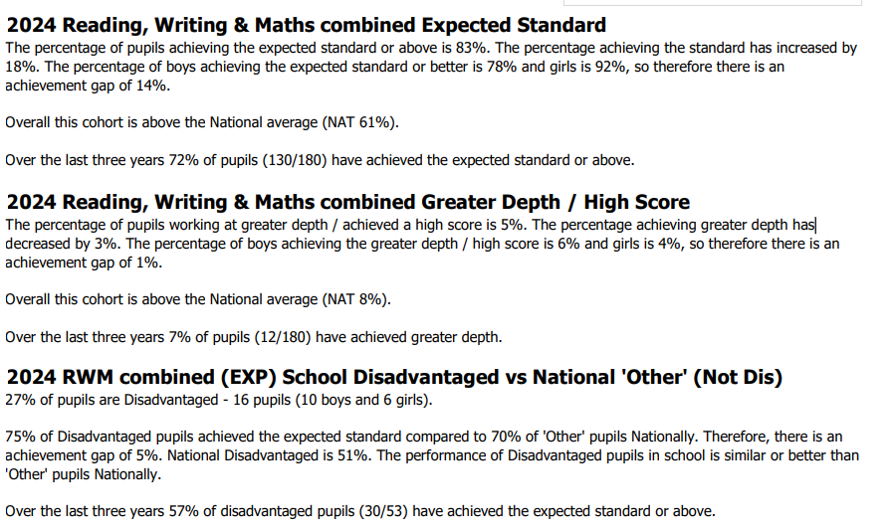

This details the impact that our pupil premium activity had on pupils in the 2023 to 2024 academic year.
Disadvantaged pupil attainment percentages for last academic year
Measure | Score
Meeting expected standard at KS2 RWM  Reading  Writing  Maths | 83% (NAT 61%)  88% (NAT 64%)  75% (NAT 67%)  81% (NAT 64%)
Meeting High standard at KS2 RWM  Reading  Writing  Maths | 6 %  25%  6%  25%

RWM combined 2024 National: 61%

There were no progress measures for the academic year 2023/24.

Externally provided programmes
Please include the names of any non-DfE programmes that you purchased in the previous academic year. This will help the Department for Education identify which ones are popular in England
Programme | Provider
Maths /Reading/ Science – individualised support programme | CENTURY
X Tables Rockstars | TT Rockstars
Data analysis / demographic analysis / Assessment / | Anthony Conlin - The School data Company
Family and Nurture support | Relational Inclusion Champion (RIC)
EduKey | Provision Map Writer

