**Holden Clough Primary School**

**Food Policy**

**(including Packed Lunches and Snacks)**

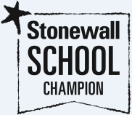

**Statement of intent**

At Holden Clough Community Primary School, we know that what pupils eat and drink at school is important. We aim to have a school where the teaching and learning about food and nutrition that occurs in our curriculum fully supports, and is supported by, the provision and opportunities for eating and drinking within school.

We acknowledge the important connection between a healthy diet and a pupil’s ability to learn effectively and achieve high standards in school. We also acknowledge that we can play a key role in supporting the wider community to adopt a positive attitude to a healthy lifestyle.

We understand that sharing food is a fundamental experience for all people; a primary way to nurture and celebrate our cultural diversity and an excellent bridge for building friendships, and inter-generational bonds.

1. **Legal framework**

This policy has due regard to statutory legislation, including, but not limited to, the following:

• The Requirements for School Food Regulations 2014

• The Products Containing Meat etc. (England) Regulations 2014

• The Food Safety (General Food Hygiene) Regulations 1995 (as amended)

• The School Standards and Framework Act 1998

• The Education Act 1996 (as amended)

This policy also has due regard to guidance, including, but not limited to, the following:

• DfE ‘School food in England’ 2016

• The School Food Plan ‘School Food Standards: A practical guide for schools their cooks and caterers’ 2014

1. **Roles and responsibilities**

The governing body is responsible for:

• The provision of school food at Holden Clough Primary School.

• Ensuring procedures are in place to provide school lunch for pupils where a meal is requested and the pupil is eligible for free school meals, or it would not be unreasonable for lunches to be provided.

• Deciding on the form that school lunches take, and ensuring that all lunches, and any other food or drink, meets the School Food Standards.

• Providing hot lunches, wherever possible, to ensure that all pupils are able to eat one hot meal a day.

• Providing free school meals to a pupil if the pupil and/or their parent meets the eligibility criteria within the Education Act 1996.

• Ensuring that all drinking water is provided free of charge at all times.

• Ensuring that all facilities provided to eat any food that pupils bring into school are free of charge.

• Providing facilities to eat food, which include accommodation, furniture and supervision, so pupils can eat their food in a safe and social environment.

• Providing lower-fat milk or lactose-reduced milk at least once a day during school hours.

• Ensuring that milk is provided free of charge to infant and benefits-based free school meals pupils.

• Providing a free piece of fruit or vegetable outside of school lunch hours for pupils between four and six years old who are eligible through the School Fruit and Vegetable Scheme.

• Receiving regular reports on compliance with the school food standards and the take-up of school lunches, as well as the financial aspects of school food provision.

• Ensuring that there is coordination across all catering services sought by the school, in order to guarantee compliance with school food standards.

1. **Current food-based standards for school lunches**

**Starchy food:**

• One or more portions of bread, pasta, noodles, rice, potatoes, sweet potatoes, yams, millet or cornmeal will be provided every day.

• Three or more different portions of bread, pasta, noodles, rice, potatoes, sweet potatoes, yams, millet or cornmeal will be provided each week – one or more of these will be wholegrain.

• A type of bread with no added fat or oil will be available every day.

**Fruit and vegetables:**

• One or more portions of vegetables (all types) will be available every day.

• Three or more different types of vegetables will be provided each week.

• One or more portions of fruit (all types) will be available every day.

• Three or more different types of fruit will be provided each week.

• A fruit–based dessert with a content of at least 50 percent fruit, measured by the volume of raw ingredients, will be provided two or more times each week.

**Meat, fish, eggs, beans and other non-dairy sources of protein:**

• A portion of meat, fish, eggs, pulses and beans (not including green beans), or other non-dairy sources of protein, will be provided every day.

• A portion of meat or poultry will be provided on three or more days every week.

• Oily fish will be provided once or more every three weeks.

• A portion of non-dairy sources of protein will be provided on three or more days every week.

**Milk and dairy:**

• A portion of cheese, yoghurt, fromage frais or custard will be provided every day.

**Food high in fat, sugar and salt:**

• Savoury crackers or breadsticks which are served with fruit and vegetables or milk and dairy may be provided as part of school lunches.

1. **Food provided as part of a school lunch or otherwise**

* Starchy food, as outlined in section 3 of this policy, which is cooked in fat or oil, will not be provided on more than two days each week.
* A meat or poultry product (manufactured or homemade and meeting the legal requirements) will be provided no more than [primary schools only] once a week.
* No meat will be provided if it contains any carcase parts, in accordance with The Products Containing Meat etc. (England) Regulations 2014.
* No economy burgers will be provided, as defined in The Products Containing Meat etc. (England) Regulations 2014.
* No more than two portions of food that has been deep-fried, batter-coated or breadcrumb-coated will be provided each week.
* No more than two portions of food which include pastry will be provided each week.
* No snacks other than seeds, vegetables and fruit with no added salt, sugar or fat will be provided. Where dried food is provided, it will have no more than 0.5 percent vegetable oil as a glazing agent.
* Confectionery will not be provided.
* Salt will not be available to add to food after the cooking process is complete.
* The only drinks that will be provided are as follows:

plain water (still or carbonated)

lower-fat milk or lactose-reduced milk

NB. Whole milk may be provided for pupils up to the end of the school year in which they reach five-years-old.

1. **Food provided otherwise than as part of a school lunch**

* Either fruit or vegetables, or both, will be available in any place on the school premises where food is provided.
* Savoury crackers and breadsticks will not be provided.
* Cakes and biscuits will not be provided.
* Desserts will not be provided, other than yoghurt or fruit-based desserts.

**Portion sizes and food groups**

The school will use the following portion sizes and food groups for school lunches, in accordance with The School Food Plan’s ‘School Food Standards: A practical guide for schools their cooks and caterers’ guidance document.

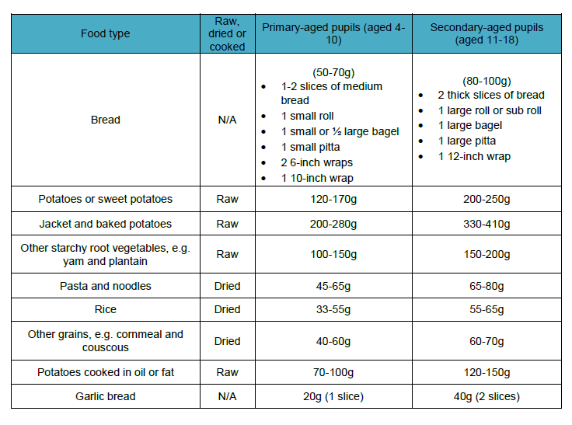

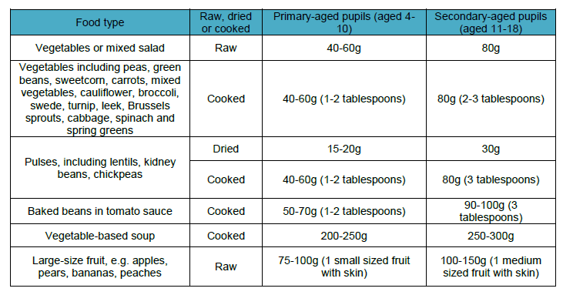

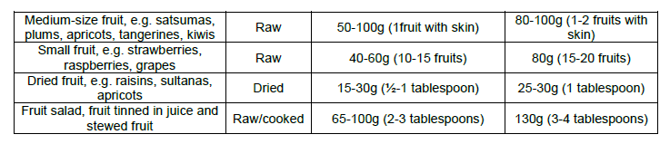

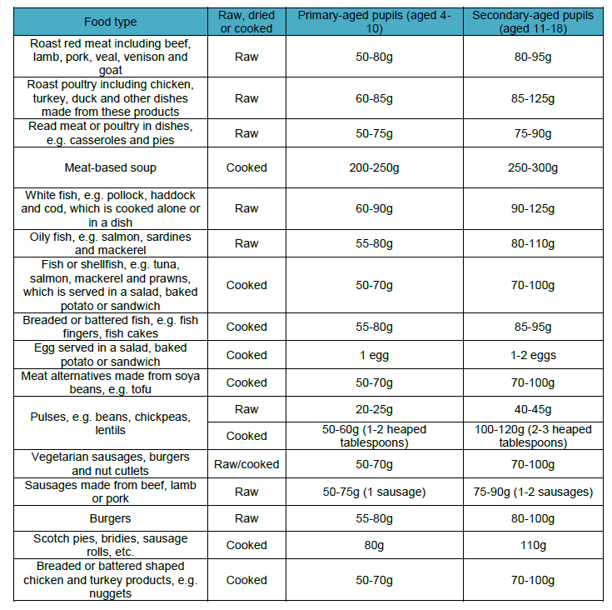

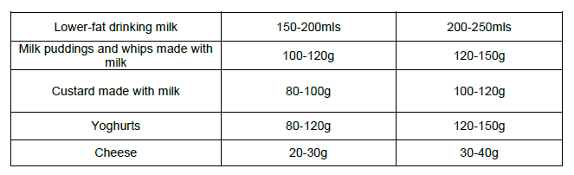

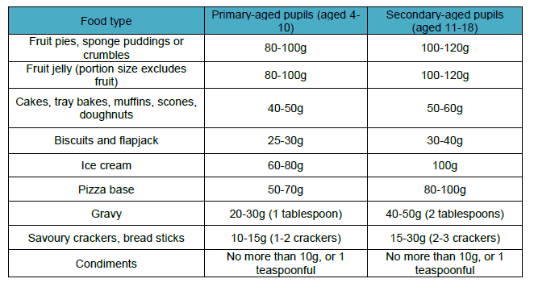

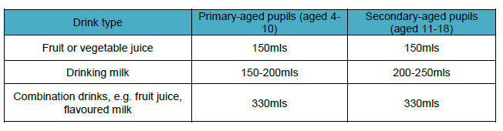

1. **Exemptions to the school food regulations**

The Requirements for School Food Regulations 2014 do not apply to food that is provided:

• At parties or celebrations to mark religious or cultural occasions.

• At occasional fund-raising events.

• As rewards for achievement, good behaviour or effort.

• For use in teaching in food preparation and cookery skills, provided that any food prepared is not served to pupils as part of a school lunch.

• On an occasional basis by parents or pupils.

1. **Healthy eating statement**

The school will use healthier cooking methods to contribute to healthy eating, such as the following:

• Using less fat in cooking

• Baking foods rather than frying them

• Increasing use of fats/oils that are high in polyunsaturated fats

• Reducing use of sugar in recipes

• Avoiding using additional salt in cooking processes

• Increasing the use of food items containing high amounts of fibre

All menus created will be in accordance with the nutritional standards outlined in section 3 of this policy.

The school will encourage all pupils to adopt healthy lifestyles, both through a nutritional diet and regular exercise, during assemblies, PE lessons, themed days/ weeks and personal, social and health education (PSHE).

1. **Catering service standards**

* Menus will be shared and clearly displayed and, where possible, will contain nutritional information.
* Menus will adhere to statutory nutritional standards.
* Menus will reflect parents’ and pupils’ preferences, cultural, religious and special dietary needs.
* Parents’ and pupils’ feedback will be encouraged and, where possible, changes made to increase customer satisfaction.
* The kitchen and serving areas will be kept clean and tidy at all times, both before, during and after preparation and cooking, in accordance with The Food Safety (General Food Hygiene) Regulations 1995 (as amended).
* The catering team will be suitably trained and will have an appropriate recognised qualification in food hygiene.
* The catering team will be clean and tidy in appearance and will be courteous to all pupils, staff and parents.
* The catering team will adhere to the service times, start and finish, agreed by the headteacher.
* Pupils entitled to free school meals will be treated with sensitivity.

**Purchasing food**

* All food items are purchased from reputable suppliers to ensure compliance with quality standards:
* The school places stringent contractual demands on catering suppliers in support of legislative requirements and favourable trade operating practices.
* All food products and ingredients are checked for acceptability, i.e. nutritional specifications, genetically modified organism requirements and nut ingredients.
* All products identified as acceptable for inclusion in our range are compared for ingredient and nutritional value against set specification criteria before being incorporated into the menus.
* The school continues to place emphasis on customer response to new products; throughout this process, the school will liaise and consult with the school community, including parents, to ensure acceptable quality.

1. **Food and drink in packed lunches (brought from home)**

We encourage all children to eat school lunches. However, parents/ carers of pupils wishing to have packed lunches are expected to provide their children with packed lunches which are in line with our packed lunch standards (see below). The purpose of these packed lunch standards is to ensure that all packed lunches brought from home and consumed in school (or on school trips) provide pupils with healthy and nutritious food that is similar in quality to food served in schools, which is required to meet national standards.

# The school will provide appropriate and attractive facilities for pupils eating packed lunches and ensure that free, fresh drinking water is available at all times.

# The school will work with parents to encourage packed lunches to meet the standards listed below.

# As fridge space is not available, pupils are advised to bring packed lunches in insulated bags with freezer blocks where possible.

# Wherever possible the school will enable pupils eating packed lunches and pupils eating school lunches to sit together.

# **Packed lunches should include:**

# at least one portion of fruit and one portion of vegetables every day.

# meat, fish, eggs, or a non-dairy protein (e.g. lentils, kidney beans, chickpeas, houmous, falafel) every day.

# oily fish, such as salmon, at least once every three weeks.

# a starchy food such as any type of bread (white or wholegrain rolls, pitta bread or wraps), pasta, rice, couscous, noodles, potatoes or another cereal every day.

# a dairy food such as milk, cheese, yoghurt, fromage frais or custard every day.

# a drink of water, fruit juice or smoothie (maximum portion 150 mls), semi-skimmed, 1% fat or skimmed milk, yoghurt or another milk drink.

# **Packed lunches can occasionally include:**

# meat products such as sausage rolls, individual pies, corned meat and sausages.

# cakes and biscuits, but encourage your child to eat these as part of a meal.

# **Packed lunches should not include:**

# salty snacks such as crisps - instead include seeds, vegetables and fruit with no added salt, sugar or fat. Snack a Jacks are allowed.

# confectionery such as chocolate bars, chocolate-coated biscuits, cereal bars, processed fruit bars and sweets.

# sugary soft drinks, such as squash and fizzy drinks (even if labelled as ‘sugar-free’, ‘no-added sugar’ or ‘reduced sugar’ as these drinks can contribute to tooth decay and provide little nutritional value).

# **Assessment, evaluation and reviewing packed lunches**

We fully respect individual parent’s food choices for their children and understand that there are many different needs and tastes. We want to work with parents to educate our children about healthy dietary choices so that the children, through the understanding of a balanced diet, will develop a greater appreciation of a healthy lifestyle.

* On a daily basis whilst supervising in the dining hall the senior leadership team monitor what children have in their lunchboxes. This is an opportunity for them to talk with the children about their lunchboxes and to encourage healthy eating and drinking.

# Healthy lunches will be rewarded by stickers / certificates / congratulatory letters home / etc.

# Where packed lunches that aren’t in line with the above standards, a reminder will be included in the packed lunch to go home.

# If a child regularly brings a packed lunch that does not conform to the policy then the school will contact the parents/carers to discuss this.

## **Healthy Snacks**

All children in KS1 and EYFS receive a free piece of fruit or vegetable everyday as part of the Governments School Fruit and Vegetable Scheme.

As children move up into KS2, if they wish to have a break time snack, they are currently required to bring fruit or vegetables from home. No crisps, chocolate, sweets or nuts should be sent to school.

Treats that are sent into school to celebrate birthdays are not allowed. If children would like to bring something in, to celebrate their birthday, they are encouraged to bring in a book to donate to their class library. Their book will be shared with the class and their name will be recorded inside the cover, for all to see.

Throughout the day, the drinking of water is encouraged in school. Children have access to water coolers to fill their water bottles. Cordial or fizzy drinks should not be brought into school.

# **Special Diets /Allergies**

The school recognises that some pupils may have verified medical conditions requiring special diets, which may impact on diet. In this case, parents/carers are urged to contact the school SENDCo – Miss Boult or a member of the senior leadership team to discuss dietary requirements.

For these reasons’ pupils are:

* not permitted to swap food items.
* not permitted to bring nuts and nut products in packed lunchboxes.

# **Sharing the policy**

# The school will ensure that all parents/carers are aware of the policy e.g.by sharing information via the school newsletter, website, prospectus, in assemblies etc.

# The school will use opportunities such as parents’ evenings and healthy living weeks to promote this policy as part of a whole school approach to healthier eating.

# **12. Monitoring and review**

* This policy will be reviewed by the headteacher in conjunction with the PSHE coordinator on a bi-annual basis.
* Any changes needed to this policy, will be implemented by the headteacher and PSHE Coordinator.
* Any changes to the policy will be clearly communicated to all members of staff, catering teams and parents/carers.

|  |  |  |  |
| --- | --- | --- | --- |
| Signed by: | | | |
|  | Headteacher | Date: |  |
|  |  |  |  |
|  | Chair of governors | Date: |  |