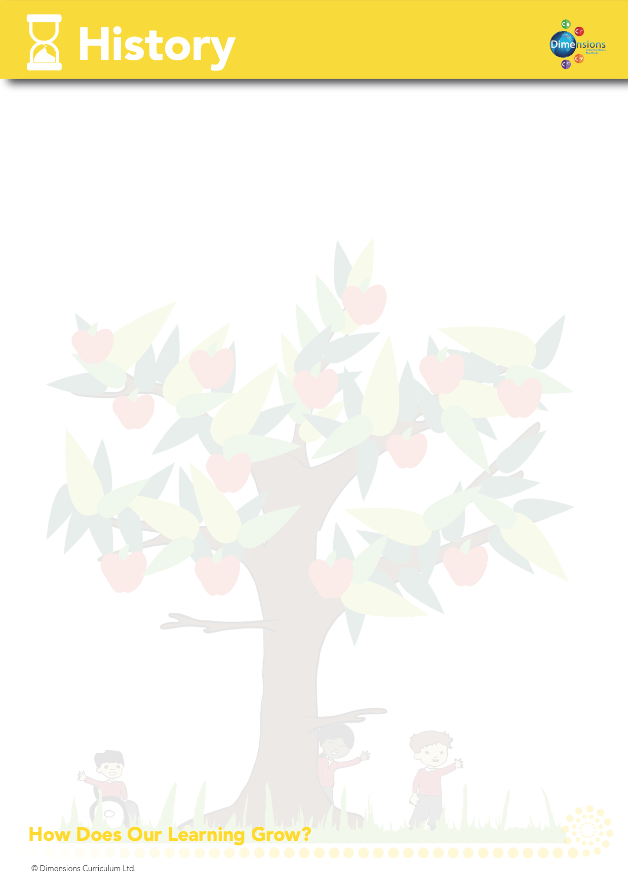

Why is History important?

History is important because it helps pupils to understand and interpret the past, and therefore, the present.

Through history, pupils develop a deeper cross-cultural awareness and understanding of their own and others’ heritage, through looking at evidence and asking and answering questions.

In history, we can analyse successes and failures, which, in turn, teaches us to learn from our mistakes.

When is History taught?
History is taught through thematic units. The attached overview (Appendix 1) maps out which thematic units feature this subject and the Long-Term Plan (Appendix 2) clearly shows the objectives taught.

How is History taught?

History is taught through a combination of subject knowledge, historical skills, enquiry and fieldwork. Learning takes place both inside and outside the classroom.

What do we learn about in History?

We learn about the following:-
Old Things
Wars (World Wars, Civil Wars)
The Ancient Greeks
The Inuits
Roman Empire and Invasions
Inventors e.g. Thomas Edison

The Mayans
The Benin
Famous historical figures
Broadcasting
Religions
Democracy
Transport
Extinction
Animation
Technology e.g. the Internet and World Wide Web
The Moon Landing
Significant local history figure / event
Apartheid / Anti-Semitism
Discovery of America / Native Americans
Legacy

Who do we learn about in History?

We learn about the following individuals:-

Thomas Edison
Walt Disney
Mother Teresa
Neil Armstrong
Roman Emperors and rulers
Martin Luther-King
Nelson Mandela
Rosa Parks
Various World Leaders
Tim Berners-Lee
John Logie Baird
Steve Jobs
Carl Linnaeus

How do we assess and monitor History?

Teachers assess children’s knowledge, understanding and skills in History by making observations within class and by analysis of their written evidence. As part of our assessment for learning process, children will receive both verbal and written feedback as a means of development.

