Holden Clough Primary School

PSHE Policy

Contents:
Statement of intent
Aims and objectives
- Legislation
- Meeting Requirement
- Organisation of the programme
- Training of staff
- Delivery of the programme
- Working with parents
- Equal opportunities
- Confidentiality
- Bullying incidents
- Monitoring and review

Appendices
  - PSHE at Holden Clough Primary School- overview Nursery-Year 6
  - Extremism and Radicalisation Additional Units
  - Substance Related Abuse Additional Units

Statement of intent
At Holden Clough Primary we understand the importance of developing pupil’s knowledge, skills and attributes in order to keep themselves healthy and safe whilst introducing them to the opportunities, challenges and responsibilities they will face growing up and preparing them for life and work in the future.
PSHE education is embedded in daily life at Holden Clough and we actively promote the moral, cultural, mental and physical development of our pupils. This helps to foster their wellbeing and develop character and personal attributes that we believe are fundamental to our pupils being happy, successful and productive.
This policy, in line with the new whole school Dimensions Curriculum and PSHE Programme – 3D PSHE, reflects the 2020 guidance and covers all aspects of Relationships Education and Health Education in an age-appropriate way.

Aims and objectives
The National Curriculum states that ‘all schools should make provision for personal, social, health and economic education (PSHE), drawing on good practice.’

According to the Education Act 2002 and the Academies Act 2010, the PSHE curriculum should be a balanced and broadly-based curriculum which ‘promotes the spiritual, moral, cultural, mental and physical development of pupils at the school and of society, and prepares pupils at the school for opportunities, responsibilities and experiences of later life.’

There are three underlying core themes taught throughout Dimensions 3D PSHE, within which there is broad overlap and flexibility: -

- Health and Wellbeing
- Relationships
- Living in the Wider World

Pupils are encouraged to participate in a wide variety of activities, enabling them to make significant contributions to both life in school and within the wider community. This allows them to become aware of their skills and talents, develop their self-worth, learn to work as part of a team and take greater responsibility for their own learning. In doing so, they are able to reflect and evaluate on how they are making progress.

The 3D PSHE Programme provides pupils with the means to handle many of the social, cultural, spiritual, physical and moral issues that occur throughout life.

3D PSHE helps pupils to develop and demonstrate skills and attitudes that will allow them to participate fully, and contribute positively, to life in modern Britain. Pupils learn to respect similarities and differences between our diverse cultures in order to build successful and meaningful friendships and relationships that are vital to the world we live in.

Dimensions 3D PSHE supports the development of the attitudes, values, skills and behaviour which enable pupils to: -

- Live healthy lifestyles
- Address personal hygiene
- Develop an awareness of changing and growing
- Deal with different emotions in an appropriate way
- Keep safe
- Communicate well with others and work as a team
- Define, identify and know how to respond to bullying
- Know where and how to seek help when needed
- Treat everybody with respect
- Form and build positive relationships
- Understand the reasons for rules, and their responsibility to keep them
- Learn about their responsibility in caring for others
- Be active in their own learning
- Be active within their community
- Manage money well
- Keep safe online
- Self-assess and identify their strengths and weaknesses
- Know how to make emergency calls
- Know basic First Aid
- Work collaboratively and respectfully
- Appreciate diversity
- Empathise with other points of view
- Express opinions clearly
- Understand the changes that occur in puberty
- Develop strategies for managing changing emotions

Legislation
Maintained schools are required to have an up-to-date policy for PSHE. This Dimensions 3D Primary PSHE Policy is informed by the following links:-

This policy will be compliant with the following guidance:
- DfE ‘Sex and Relationship Education Guidance’ 2000 Guidance on Relationships, Relationships and Sex Education, and Health Education
- DfE ‘Science programmes of study: key stages 1 and 2’ 2013
- PSHE Association Guidance 2019 PSHE Association
- The Academies Act 2010 Academies Act 2010
- DfE Relationship and Health Education Guidance July 2019
- Children’s Act 1989
- Equality Act 2010
- Education Act 2011
- Parliament UK Report 2019

- Children and Social Work Act 2017

- Common inspection framework: education, skills and Early Years from September 2015.

- 04/04/17 amendments to the Children and Social Work Bill about Mandatory Relationship Education in Primary Schools by 2019.

- OFSTED Exploring the school’s actions to prevent Homophobic and Transphobic bullying – all age groups September 2013 ref no 120181.

2. Meeting Requirement

Under the Education Act 2002/ Academies Act 2010 all schools must provide a balanced and broadly- based curriculum which:

Promotes the spiritual, moral, cultural mental and physical development of pupils at the school and of society.

Prepares pupils at school for the opportunities, responsibilities and experiences of later life.

PSHE is set within the wider legislative context – The 2006 Education and Inspections Act laid duty on Governing Bodies to ‘promote the wellbeing of pupils at the school’. The duty came in effect in 2007.

We welcome our duties under the Equality Act 2010 that we have a duty not to discriminate against people on the basis of their age, disability, gender, gender identity, pregnancy or maternity, race, religion or belief and sexual orientation.

We believe this policy is in line with the Equality Act 2010 as it is fair, it does not prioritise or disadvantage any pupil and it helps to promote equality at this school.

Related policies:

Anti-Bullying Policy

Behaviour Policy

RE (Relationship Education) Policy

Child Protection and Safeguarding Policy

Curriculum Policies (PE, Science)

DAAT Policy

E-safety Policy

Organisation of the programme

The PSHE programme will be developed in conjunction with the views of teachers, pupils and parents by SLT and the PSHE coordinator, in accordance with DfE recommendations.

The majority of the Relationship and DAAT programme will be delivered through the personal, social, health and economic (PSHE) education, with statutory aspects taught via the science curriculum.

In EYFS, key stage 1 and key stage 2, the topics are broken down into specific areas that will be taught appropriate to pupils’ ages within the 3D Scheme.

Elements of the topics for key stage 1 and 2 are statutory in accordance with the science national curriculum and therefore must be taught.

Training of staff

All staff members at the School will undergo training to ensure they are up-to-date with the requirements of the PSHE curriculum.

Training of staff will also be scheduled around any updated guidance on the programme and any new developments in curriculum guidance.

Delivery of the programme

At Holden Clough Community Primary school we follow the 3D PSHE scheme as well as some lessons that are taught through year group topics.

Classes may be taught in gender-segregated groups dependent upon the nature of the topic being delivered at the time, and the cultural background of pupils where it is only appropriate to discuss the body in single gender groups.

Throughout every year group, appropriate diagrams, videos, books, games, discussion and practical activities will be used to assist learning.

Inappropriate images, videos, etc. will not be used, and resources will be selected with sensitivity given to the age and cultural background of pupils.

Pupils will be prevented from accessing inappropriate materials on the internet when using such to assist with their learning. The prevention measures taken to ensure this, are outlined in the School’s E-safety Policy, and Acceptable Terms of Use Agreement.

Teachers will establish what is appropriate for one-to-one and whole-class settings, and alter their teaching of the programme accordingly.

Teachers will ensure that pupils’ views are listened to and will encourage them to ask questions and engage in discussion. Teachers will answer questions sensitively and honestly.

The school understands that pupils with special education needs and disabilities (SEND) are entitled to a broad and balanced curriculum and the programme will be designed to be inclusive of all pupils.

Teachers will understand that they may need to be more explicit and adapt their planning of work in order to appropriately deliver the programme to pupils with SEND.

External experts may be invited to assist from time-to-time with the delivery of the PSHE curriculum, but will be expected to comply with the provisions of this policy.

Relationships Education (Statutory)
The focus of 3D PSHE in primary school is on teaching the fundamental building blocks and characteristics of positive relationships, with particular reference to friendships, family relationships and relationships with other children and adults.
3D PSHE teaches pupils, in an age-appropriate way, what a healthy relationship is, enabling them to form a clear understanding of the features of positive relationships that are likely to lead to fulfilment, happiness and security. Pupils learn what friendship is, what family means and who the people are who can support them.
Our school’s careful use of 3D PSHE teaches about families in a well-judged and sensitive way, based on a clear knowledge of the pupils and their circumstances, reflecting that some children have different family structures and supportive relationships. They learn how to take turns, how to treat each other with kindness, consideration and respect, the importance of honesty and truthfulness, permission seeking and giving, and the concept of personal privacy. Establishing personal space and boundaries, showing respect and understanding, including the differences between appropriate and inappropriate or unsafe physical, and other, contact are the forerunners of teaching about consent, which takes place at secondary.
3D PSHE lessons teach pupils about online safety and appropriate behaviour online, including sharing data and ways in which information provided by users may be used negatively.
3D PSHE’s Relationship Education encourages the development and practice of resilience and perseverance, self-respect and self-worth. Pupils are also helped to develop personal attributes including honesty, integrity, courage, humility, kindness, generosity, trustworthiness and a sense of justice. In 3D PSHE, this is achieved through a plethora of exciting and innovative learning experiences for in active citizenship.
Pupils are taught about positive emotional and mental wellbeing, including how friendships can support mental wellbeing.
They also learn about safe relationships, focusing on boundaries and privacy and ensuring that they understand that they have rights over their own bodies. This also covers understanding boundaries in friendships with peers, in families and with others, in all contexts, including online. In 3D PSHE, pupils are clearly taught how to report concerns and seek advice when they suspect or know that something is wrong. Of paramount importance is ensuring the balance between informing children about making sensible decisions to stay safe (including online) without frightening them unnecessarily, whilst also making it clear that it is never the fault of a child who is exploited or abused, and why victim blaming is always wrong.

3D PSHE Extremism and Radicalisation Unit
We use the 3D PSHE Extremism and Radicalisation Units. In KS1 we cover understanding the differences between ‘fact’ and ‘opinion’; recognising and respecting similarities and differences between people; how to deal with confrontation; understanding that difference is a positive feature. In KS2 we look at how to deal with peer pressure; how extremism manifests itself; homophobia and racism as extremist behaviours; terrorism. (see appendix b)
Fact and Op

3D PSHE Substance Related Abuse Unit
We use the 3D Substance Related Abuse Unit. This covers keeping safe;
understanding some of the consequences of risk-taking; knowing some of the different forms addiction can take; the names of the most common drugs; how advertising influences our choices. (see appendix c)

Working with parents

The school understands that the teaching of some aspects of PSHE may be of concern to parents/carers.

The school will ensure that no teachers express their personal views or beliefs when delivering the programme.

Parents/carers will be consulted about this policy and curriculum content through parent meetings, working parties and class half termly newsletters

Parents will be given the written option of withdrawing their child from Sex Education sessions (See RE Policy).

The school respects the legal right of parents/carers to withdraw their child from all or part of the sex and relationship education programme, except for those statutory parts included in the science national curriculum. (See RE Policy)

Equal opportunities

The school understands and abides by The Equality Act 2010, and fully respects the rights of pupils and staff members, regardless of any protected characteristics that he/she may have.

The school is dedicated to delivering the PSHE programme with sensitivity and respect, avoiding any derogatory or prejudicial terms which may cause offence.

Confidentiality

Confidentiality within the classroom is an important component of PSHE education, and teachers are expected to respect the confidentiality of their pupils as far as is possible.

Teachers must, however, alert the headteacher about any suspicions of inappropriate behaviour or potential abuse as per school’s Child Protection Policy.

Bullying incidents

The school has a zero-tolerance approach to bullying. Any bullying incidents caused as a result of the sex and relationship education programme, such as those relating to sexual orientation, will be dealt with as seriously as other bullying incidents within the school.

Any occurrence of these incidents should be reported to a member of school staff, who will then discipline the pupil once he/she is on school premises.

These incidents will be dealt with following the process in our Anti-bullying and Acceptable Behaviour from Parents Policy . The headteacher will decide whether it is appropriate to notify the police or an anti-social behaviour coordinator in their LA of the action taken against a pupil.

Monitoring and review

This policy will be reviewed by the headteacher in conjunction with the PSHE coordinator on a bi-annual basis.

Any changes needed to the policy, including changes to the programme, will be implemented by the headteacher and PSHE Coordinator.

Any changes to the policy will be clearly communicated to all members of staff.

Appendix a:
PSHE at Holden Clough Primary School Primary

The outline below shows an overview of where PSHE lessons are covered and how they build on the previous year. As well as the Core Themes taught through the 3D scheme, additional lessons are also delivered through half termly topics.

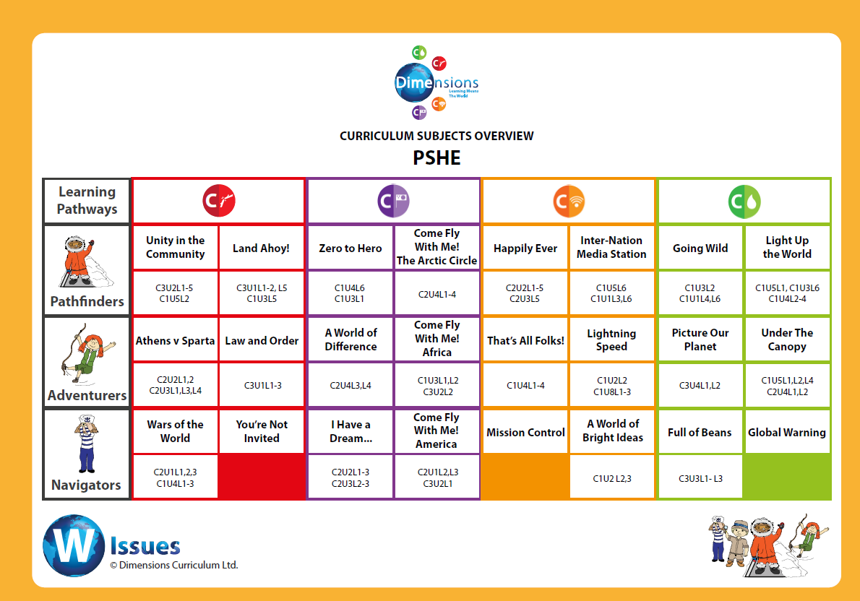

Nursery Overview

Making relationships | Lessons
Plays in a group, extending and elaborating play ideas  (DM 30-50 months) | Lesson 1 ‘Let’s Play Shops’
Initiates play, offering cues to peers to join in  (DM 30-50 months) | Lesson 2 ‘Who’s Playing’
Responds to what others say or do and keeps play going  (DM 30-50 months) | Lesson 2 ‘Who’s Playing’
Demonstrates friendly behaviour, initiating conversations and forming good relationships with peers and familiar adults  (DM 30-50 months) | Lesson 4 ‘Good Friends’
Self Confidence / Awareness | Lessons
Selects and uses activities and resources with help  (DM 30-50 months) | Lesson 5 ‘Make Your Choice’
Enjoys responsibility of carrying out small tasks  (DM 30-50 months) | Lesson 6 ‘Odd Jobs’
Talks confidently to other children when playing  (DM 30-50 months) | Lesson 7 ‘Chatterbox!’
Communicates freely about own home and community  (DM 30-50 months) | Lesson 8 ‘Where I Live’
Shows confidence in asking adults for help  (DM 30-50 months) | Lesson 9 ‘Can You Help?’
Welcomes and values praise for what they have done  (DM 30-50 months) | Lesson 10 ‘Well Done!’
Is more outgoing towards unfamiliar people and more confident in new social situations (DM 30-50 months) | Lesson 11 ‘A New Baby’

Managing Feelings / Behaviour | Lessons
Begins to accept the needs of others  (DM 30-50 months) | Lesson 12 ‘Deaf Girl’
Takes turns and shares resources, sometimes with support  (DM 30-50 months) | Lesson 13 ‘Fair Shares’
Adapts behaviour to different events, social situations and changes  in routine  (DM 30-50 months) | Lesson 14 ‘The Pantomime’
Is aware of own feelings and knows that some actions and words  can hurt others’ feelings  (DM 30-50 months) | Lesson 15 ‘You Smell!’
Can usually tolerate delay when needs are not immediately met,  and understands wishes may not always be met  (DM 30-50 months) | Lesson 16 ‘A Waiting Game’

Reception Overview

Making relationships | Lessons
Initiates conversations, attends to and takes account of what others say  (DM 40-60 months)  It’s all about…taking part! | Lesson 7 ‘An Old Friend’
Explains own knowledge and understanding  (DM 40-60 months)  It’s all about… taking part! | Lesson 16 ‘All Join In’  Lesson 23 ‘Eid Mubarak!’
Asks appropriate questions of others  (DM 40-60 months)  It’s all about… being smart! | Lesson 11 ‘I Feel Poorly’  Lesson 18 ‘A Piece of Cake’
Takes steps to resolve conflicts with other children by finding compromises  (DM 40-60 months)  It’s all about…where to start! | Lesson 4 ‘It’s Your Turn’
Plays co-operatively, taking turns with others  (ELG)  It’s all about…taking part! | Lesson 4 ‘It’s Your Turn’  Lesson 24 ‘Playtime Games’ Lesson 25 ‘Litter Bug!’
Takes account of one another’s ideas about how to organise an activity  (ELG)  It’s all about… having heart! | Lesson 10 ‘Rainy Days’  Lesson 19 ‘Busy Body’
Shows sensitivity to others’ needs and feelings and form positive relationships with adults and other children  (ELG)  It’s all about… having heart! | Lesson 1 ‘Hide and Seek’  Lesson 7 ‘An Old Friend’  Lesson 14 ‘Family Fun’  Lesson 23 ‘Eid Mubarak!’

Self Confidence / Awareness | Lessons
Confident to speak to others about own needs, wants, interests and opinions  (DM 40-60 months)  It’s all about… being smart! | Lesson 3 ‘I Like...’  Lesson 10 ‘Rainy Days’  Lesson 25 ‘Litter Bug!’
Can describe self in positive terms and talk about abilities  (DM 40-60 months)  It’s all about… being smart! | Lesson 8 ‘Me and You’  Lesson 15 ‘One Gold Star’

Self Confidence / Awareness | Lessons
Confident to try new activities  (ELG)  It’s all about…being smart! | Lesson 6 ‘Taking the Plunge’
Says why they like some activities more than others (ELG)  It’s all about… being smart! | Lesson 2 ‘Nan’s House’
Confident to speak in a familiar group  (ELG)  It’s all about… taking part! | Lesson 10 ‘Rainy Days’
Talks about their ideas  (ELG)  It’s all about... being smart! | Lesson 10 ‘Rainy Days’
Chooses resources they need for their chosen activities  (ELG)  It’s all about… being smart! | Lesson 18 ‘A Piece of Cake’
Says when they do or don’t need help  (ELG)  It’s all about… being smart! | Lesson 6 ‘Take the Plunge’  Lesson 17 ‘I’m Stuck’  Lesson 21 ‘Dressing Up’  Lesson 22 ‘E-Safety, Be Safe’

Managing Feelings / Behaviour | Lessons
Beginning to be able to negotiate and solve problems without aggression  (DM 40-60 months)  It’s all about…where to start! | Lesson 5 ‘What a Problem’  Lesson 25 ‘Litter Bug!’
Talks about how they and others show feelings  (ELG)  It’s all about… having heart! | Lesson 2 ‘Nan’s House’  Lesson 20 ‘The New Pet’
Talks about their own and others’ behaviour and its consequences  (ELG) It’s all about… being smart! | Lesson 12 ‘Clean and Tidy’  Lesson 13 ‘Bully Boy’  Lesson 24 ‘Playtime Games’
Works as part of a group or class, and understands and follows the rules  (ELG)  It’s all about… taking part! | Lesson 9 ‘Stick to the Rules’

Year One Overview
Autumn 1 | Core Theme 3 Unit 1 LESSON 1: Rules / Expectations - We Expect ... Core Theme 3 Unit 1 LESSON 2: Rules / Expectations - Class Charter Core Theme 1 Unit 5 LESSON 6: Internet Safety - E-Safety  Core Theme 2 Unit 4 LESSON 1: Friendship - Forever Friends Core Theme 2 Unit 4 LESSON 2: Friendship - Make Friends Core Theme 3 Unit 1 LESSON 3: Taking Turns - It's Your Turn!
Autumn 2 | Core Theme 2 Unit 1 LESSON 7: Good Manners - How Rude! Core Theme 1 Unit 4 LESSON 1: Happiness - Smile!  Core Theme 1 Unit 4 LESSON 2: Anger - Grrrr!  Core Theme 2 Unit 1 LESSON 1: Feelings - How I Feel Core Theme 2 Unit 1 LESSON 2: Responses - You and Me Core Theme 2 Unit 1 LESSON 3: Opinions - I Think...
Spring 1 | Core Theme 1 Unit 2 LESSON 4: Washing Hands - Meet Grub! Core Theme 1 Unit 1 LESSON 1: Healthy Eating - Vote Green! Core Theme 1 Unit 1 LESSON 2: Healthy Eating - Meat Eaters Core Theme 1 Unit 1 LESSON 3: Healthy Eating - Party Time! Core Theme 1 Unit 1 LESSON 4: Physical Activity - Get Physical! Core Theme 2 Unit 3 LESSON 2: Comparisons - All the Same
Spring 2 | Core Theme 2 Unit 2 LESSON 1: Definition - A Bully is...  Core Theme 2 Unit 2 LESSON 2: Unkindness - Blame Game Core Theme 2 Unit 2 LESSON 3: Behaviour - Bullying is...  Core Theme 2 Unit 2 LESSON 4: Behaviour - + and –  Core Theme 1 Unit 5 LESSON 4: Personal Safety - Secret Surprise Core Theme 1 Unit 5 LESSON 5: Emotional Safety - Getting Help
Summer 1 | Core Theme 2 Unit 3 LESSON 6: Kindness - Give a Little  Core Theme 2 Unit 4 LESSON 5: Family - My Family  Core Theme 2 Unit 4 LESSON 6: Family - Special People  Core Theme 3 Unit 1 LESSON 6: Caring - Talking to Plants  Core Theme 3 Unit 1 LESSON 4: Lending / Borrowing - The Borrowers Core Theme 3 Unit 1 LESSON 5: Sharing - Share the Booty
Summer 2 | Core Theme 1 Unit 5 LESSON 1: Sun Safety – It’s a Cover Up! Core Theme 1 Unit 5 LESSON 2: Road Safety – Green X Code Core Theme 3 Unit 3 LESSON 1: Money - Grows on Trees? Core Theme 3 Unit 3 LESSON 2: Money - Coining it in! Core Theme 3 Unit 3 LESSON 3: Money - Keep Money Safe

Year Two Overview
Autumn 1 | Core Theme 2 Unit 4 LESSON 3: Friendship - Hola! Bonjour! Core Theme 2 Unit 4 LESSON 4: Friendship - Share Alike  Core Theme 2 Unit 3 LESSON 1: Fair and Unfair - It's Not Fair! Core Theme 3 Unit 2 LESSON 1: Our School - Common Goals Core Theme 3 Unit 2 LESSON 2: Belonging - I Belong ...  Core Theme 3 Unit 2 LESSON 3: Belonging - Join Our Club! Core Theme 2 Unit 5 LESSON 7: Staying Safe – I Don’t Know You
Autumn 2 | Core Theme 2 Unit 3 LESSON 4: Right and Wrong - In the Right Core Theme 1 Unit 4 LESSON 5: Consequences - Good v Bad Core Theme 1 Unit 4 LESSON 6: Aspirations - It's a Goal!  Core Theme 2 Unit 1 LESSON 4: Co-operation – Negotiation Core Theme 2 Unit 1 LESSON 5: Co-operation - Want to Play? Core Theme 2 Unit 1 LESSON 6: Co-operation - Let's Debate!
Spring 1 | Core Theme 1 Unit 2 LESSON 5: Keeping Clean - Bath-time Core Theme 1 Unit 2 LESSON 6: Skin - Skinny Tips  Core Theme 1 Unit 2 LESSON 1: Dental Hygiene - Brushing Up! Core Theme 1 Unit 2 LESSON 2: Dental Hygiene - Bright White Core Theme 1 Unit 2 LESSON 3: Dental Hygiene - Top Teeth Core Theme 1 Unit 5 LESSON 3: Drug Safety - Magic Medicine
Spring 2 | Core Theme 1 Unit 3 LESSON 1: Similarities and Differences - Boys v Girls Core Theme 1 Unit 3 LESSON 2: The Human Body - Body Bits  Core Theme 1 Unit 3 LESSON 3: Growing Up - All Grown Up  Core Theme 1 Unit 3 LESSON 4: Changing Needs - I Need Core Theme 1 Unit 1 LESSON 5: Physical Activity - Mighty Muscles Core Theme 1 Unit 1 LESSON 6: Exercise - Workout!
Summer 1 | Core Theme 2 Unit 2 LESSON 5: Behaviour - Help Me!  Core Theme 2 Unit 3 LESSON 3: Behaviour - In My Shoes  Core Theme 2 Unit 3 LESSON 5: Teasing - Cry Baby!  Core Theme 3 Unit 2 LESSON 4: Local Citizenship - Our Local Area Core Theme 3 Unit 2 LESSON 5: Local Citizenship - Community Care Core Theme 1 Unit 3 LESSON 5: Responsibility - Who's at Fault?
Summer 2 | Core Theme 1 Unit 3 LESSON 6: Emotions – Mood Swings Core Theme 1 Unit 4 LESSON 3: Love - Three Little Words Core Theme 1 Unit 4 LESSON 4: Sadness - How to Cope Core Theme 3 Unit 3 LESSON 4: Money - Shopping List Core Theme 3 Unit 3 LESSON 5: Choices - This or That? Core Theme 3 Unit 3 LESSON 6: Enterprise - Dragons' Den

Year Three Overview
Autumn 1 | Core Theme 1 Unit 6 LESSON 1: E-Safety – Online Chat  Core Theme 1 Unit 6 LESSON 2: Online Privacy – The Secrets Jar Core Theme 1 Unit 6 LESSON 3: Online Privacy – E-Protection  Core Theme 3 Unit 1 LESSON 1: Rules – I’m In Charge!  Core Theme 3 Unit 1 LESSON 2: Thinking Ahead – Lesson Planning Core Theme 3 Unit 1 LESSON 3: Taking the Lead – Learning Time
Autumn 2 | Core Theme 2 Unit 5 LESSON 1: Friendship – Best Features Core Theme 2 Unit 5 LESSON 2: Friendship – Circles Time Core Theme 2 Unit 5 LESSON 3: Friendship - Falling Out Core Theme 2 Unit 5 LESSON 4: Friendship – The BAFAs Core Theme 1 Unit 5 LESSON 1: Loss / Separation – Lost! Core Theme 1 Unit 5 LESSON 2: Loss / Separation – Found!
Spring 1 | Core Theme 1 Unit 1 LESSON 1: Physical, Emotional and Mental – I Am Who I Am!  Core Theme 1 Unit 1 LESSON 2: Physical, Emotional and Mental – Hearts and Minds Core Theme 1 Unit 1 LESSON 3: Physical, Emotional and Mental – Three in One  Core Theme 1 Unit 2 LESSON 4: Sleep – Sweet Dreams
Spring 2 | Core Theme 2 Unit 1 LESSON 1: Clear Messages – Dot, Dot, Dash  Core Theme 2 Unit 1 LESSON 2: How to Listen – Listen Up!  Core Theme 3 Unit 2 LESSON 1: Different Communities – My Community. Core Theme 3 Unit 2 LESSON 2: School Communities – School Swap
Summer 1 | Core Theme 1 Unit 7 LESSON 1: Before Puberty – You’ve Grown!  Core Theme 1 Unit 7 LESSON 2: Visible Changes – Mind the Gap Core Theme 1 Unit 8 LESSON 1: How to Help – Who to Call  Core Theme 1 Unit 8 LESSON 2: Emergency Calls – Calling 999  Core Theme 1 Unit 8 LESSON 3: Emergency Calls – Ambulance, Now!
Summer 2 | Core Theme 1 Unit 2 LESSON 1: A Balanced Approach – Define: Healthy Core Theme 1 Unit 2 LESSON 2: Physical Exercise – Active Kids?  Core Theme 1 Unit 2 LESSON 3: Lifestyle Choices – It’s Your Choice Core Theme 2 Unit 2 LESSON 1: Working Together – Name Game Core Theme 2 Unit 2 LESSON 2: Working Together – Build It Up Core Theme 2 Unit 2 LESSON 3: Shared Goals – Better Places

Year Four Overview
Autumn 1 | Core Theme 1 Unit 6 LESSON 4: Online Privacy – It’s Personal  Core Theme 1 Unit 6 LESSON 5: Internet Use – Online Usage  Core Theme 1 Unit 6 LESSON 6: Internet Use – Age Limits  Core Theme 3 Unit 3 LESSON 1: Gender Stereotypes – His and Hers
Autumn 2 | Core Theme 2 Unit 3 LESSON 1: Reactions - Frustration  Core Theme 2 Unit 3 LESSON 2: Self-Worth – I’m a Marvel!  Core Theme 2 Unit 3 LESSON 3: Persistence and Resilience - Don’t Give Up  Core Theme 2 Unit 3 LESSON 4: Negative Persistence – Over and Over  Core Theme 1 Unit 5 LESSON 5: Feelings - Overreacting
Spring 1 | Core Theme 1 Unit 3 LESSON 1: A Balanced Diet – Plant or Animal? Core Theme 1 Unit 3 LESSON 2: A Balanced Diet – Balancing Act Core Theme 1 Unit 3 LESSON 3: Working with Food – Master Chef Core Theme 1 Unit 3 LESSON 4: Working with Food – Our Food Hall
Spring 2 | Core Theme 2 Unit 1 LESSON 3: Responding to Others – Agony Aunts Core Theme 2 Unit 1 LESSON 4: Expressing Opinions – It’s Debatable Core Theme 1 Unit 5 LESSON 3: Loss / Separation – Left Behind  Core Theme 1 Unit 5 LESSON 4: Family Changes – Two Homes
Summer 1 | Core Theme 1 Unit 4 LESSON 1: Identified Strengths – I’m Good at That Core Theme 1 Unit 5 LESSON 6: Self-Respect – Let’s Rock!  Core Theme 1 Unit 4 LESSON 2: Identified Strengths – Future Me  Core Theme 1 Unit 4 LESSON 3: Setting Goals – That’s My Goal! Core Theme 1 Unit 4 LESSON 4: Setting Goals – The Impossible Dream
Summer 2 | Core Theme 2 Unit 4 LESSON 1: Connections – Paper Chains  Core Theme 2 Unit 4 LESSON 2: Family Links – Family Tree  Core Theme 2 Unit 4 LESSON 3: Religious Views – Faith Findings Core Theme 2 Unit 4 LESSON 4: Celebrate Diversity – Inside Outside Core Theme 3 Unit 4 LESSON 1: Money Choices – A Million Dollars Core Theme 3 Unit 4 LESSON 2: Managing Money – Design Choices

Year Five Overview
Autumn 1 | Core Theme 3 Unit 1 LESSON 1: Structure – Just Imagine ...  Core Theme 3 Unit 1 LESSON 2: Law and Order – In Charge  Core Theme 3 Unit 1 LESSON 3: U.N. Rights – Our Rights  Core Theme 2 Unit 4 LESSON 5: Online Relationships – A Risky Business Core Theme 1 Unit 5 LESSON 1: Drugs – Just Say No! Core Theme 1 Unit 5 LESSON 2: Alcohol – Drink Aware
Autumn 2 | Core Theme 1 Unit 4 LESSON 1: Death and Grief – It’s Natural  Core Theme 1 Unit 4 LESSON 2: Death and Grief - Poppies  Core Theme 1 Unit 4 LESSON 3: Managing Conflict – Families at War Core Theme 3 Unit 2 LESSON 1: Community Event – We’re Cultured!
Spring 1 | Core Theme 1 Unit 1 LESSON 2: Physical, Emotional and Mental – What’s Puberty?  Core Theme 1 Unit 1 LESSON 3: Healthy Lifestyles – You Choose! Core Theme 1 Unit 5 LESSON 3: Tobacco – Up in Smoke Core Theme 1 Unit 5 LESSON 4: Substance Abuse – Let’s Be Frank
Spring 2 | Core Theme 1 Unit 1 LESSON 1: Physical, Emotional and Mental – 3-Dimensional  Core Theme 2 Unit 1 LESSON 1: Confidentiality – Secret Info  Core Theme 2 Unit 1 LESSON 2: Listening – I’m All Ears! Core Theme 2 Unit 1 LESSON 3: Responding – Scenarios
Summer 1 | Core Theme 1 Unit 2 LESSON 1: Food Choices – Secret Eaters  Core Theme 1 Unit 2 LESSON 2: Food Choices – Invention Team Core Theme 1 Unit 2 LESSON 3: Cooking – Michelin Stars  Core Theme 2 Unit 4 LESSON 1: Physical Contact – Touch Sensitive
Summer 2 | Core Theme 2 Unit 2 LESSON 1: Responding - Scrabble  Core Theme 2 Unit 2 LESSON 2: Shared Goals – It’s All Go! Core Theme 2 Unit 2 LESSON 3: Community Spirit – All Join In Core Theme 1 Unit 5 LESSON 5: Basic First-Aid – First Aids Tips

Year Six Overview
Autumn 1 | Core Theme 1 Unit 3 LESSON 1: Identified Strengths – Big Dreams Core Theme 1 Unit 3 LESSON 2: Identified Strengths – Big Achievers Core Theme 1 Unit 3 LESSON 3: Setting Goals – ‘Super Futures’ Core Theme 1 Unit 3 LESSON 4: Setting Goals – I Can Do That! Core Theme 1 Unit 5 LESSON 6: Internet Safety – Fake News
Autumn 2 | Core Theme 2 Unit 3 LESSON 1: Race and Ethnicity – United States? Core Theme 2 Unit 3 LESSON 2: Gender Stereotypes – Jobs 4 All Core Theme 2 Unit 3 LESSON 3: Culture – Cultural Feast
Spring 1 | Core Theme 1 Unit 1 LESSON 4: Physical Illness – Bleugh!  Core Theme 1 Unit 1 LESSON 6: Immunisation – One Sharp Scratch Core Theme 2 Unit 4 LESSON 3: Marriage – I Promise...
Spring 2 | Core Theme 1 Unit 1 LESSON 5: Healthy Minds – Young Minds  Core Theme 2 Unit 4 LESSON 4: Mental Wellbeing – Mind Business Core Theme 2 Unit 4 LESSON 2: Support and Care - Connections
Summer 1 | Core Theme 3 Unit 3 LESSON 1: Budgeting – Money Supermarket  Core Theme 3 Unit 3 LESSON 2: Consumer Sense – Payment Terms Core Theme 3 Unit 3 LESSON 3: Consumer Sense – A Class Catalogue!
Summer 2 | Core Theme 3 Unit 4 LESSON 1: Generating Income – Making Money Core Theme 3 Unit 4 LESSON 2: Generating Income – Raising Money

Appendix b) Extremism and Radicalisation Additional Units

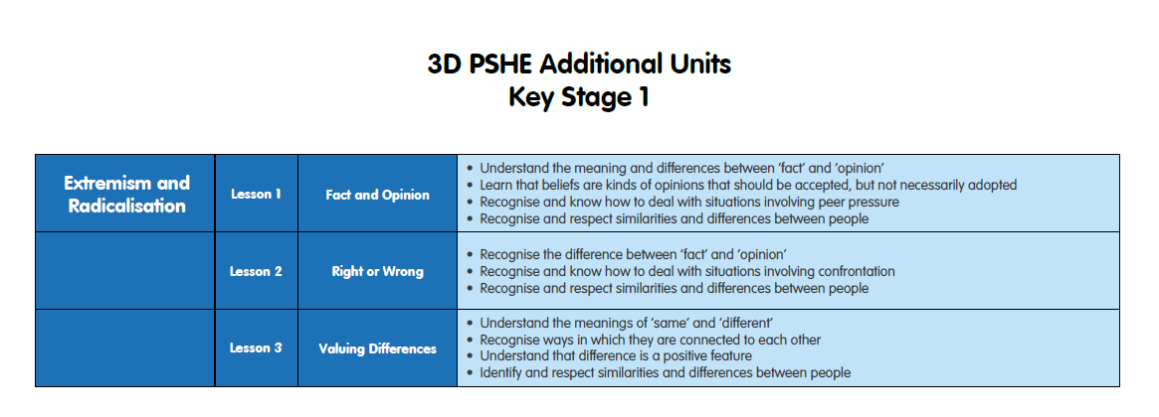

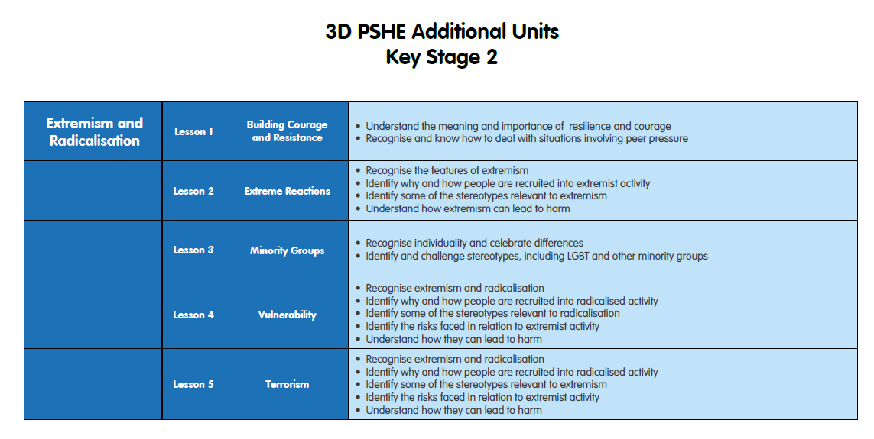

Appendix c) Substance Related Abuse Additional Units

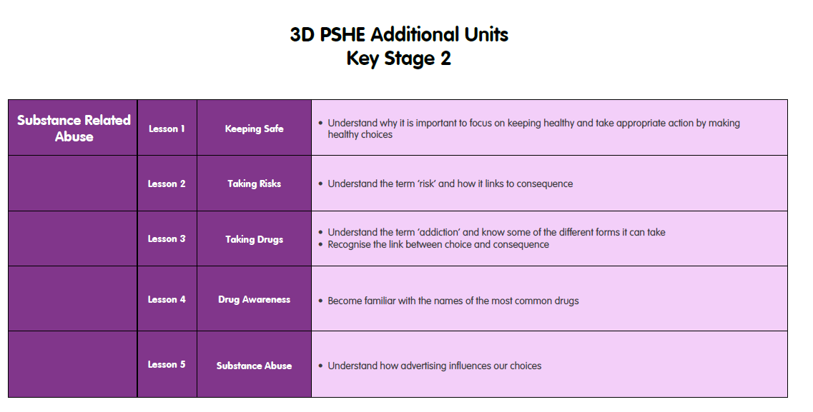

Signed by:
 | Headteacher | Date:
 | Chair of governors | Date:

